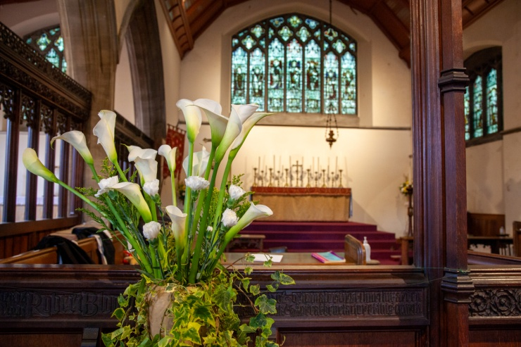
ALL SAINTS’ CHURCH,
SOUTH WIMBLEDON
Annual Report on the proceedings of the Parochial Church Council, and the general activities of the Parish, Jan – Dec 2025
Prepared for the A.P.C.M. 10th May 2026

Aims and Purposes
The Parochial Church Council of All Saints’ Church, South Wimbledon works together with our Parish Priest – Father Christopher Noke – to promote the worship, mission, outreach and care of the parish. As of March 2023 the parish entered an interregnum, but it has been agreed that Father Christopher should continue as Parish Priest with ‘Permission to Officiate’ until such time as deemed appropriate. It should be noted that the current Suspension of the Benefice expires in September 2026.
All Saints’ is a ‘Society Parish’ and ‘Episcopal Oversight’ is provided by the Bishop of Fulham. However, we also seek to co-operate fully with the Diocese of Southwark, making sure that we are properly represented on Synod, and that we engage with, and support, as many Diocesan initiatives as possible. To this end we have three representatives on the Merton Deanery Synod and two on the Southwark Diocesan Synod. It should be noted that Christopher (Bishop of Southwark) retires this year and the Diocese will be in the hands of Bishop Rosemary Mallett until such time as a new appointment is made.
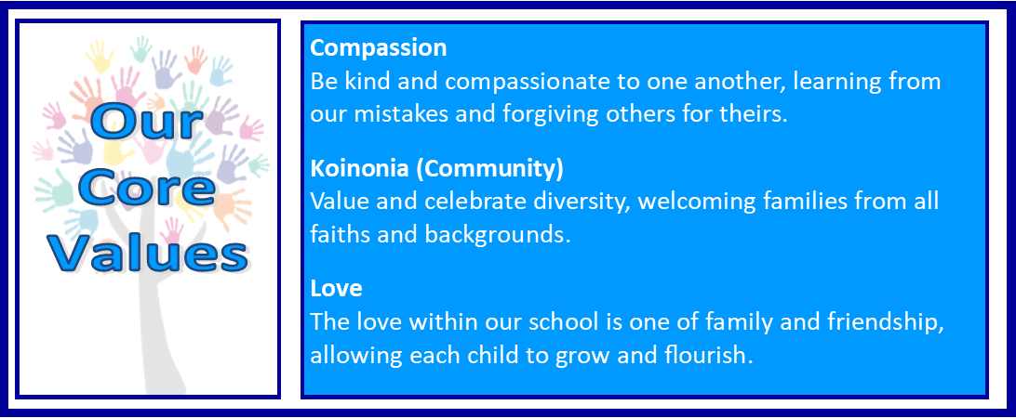
Promoting and nurturing the links that exist between the church and our primary school is also part of the council’s remit, and several members serve on the Governing Body. “Growing stronger together in God’s Love’ is the collective ethos for both church and school.
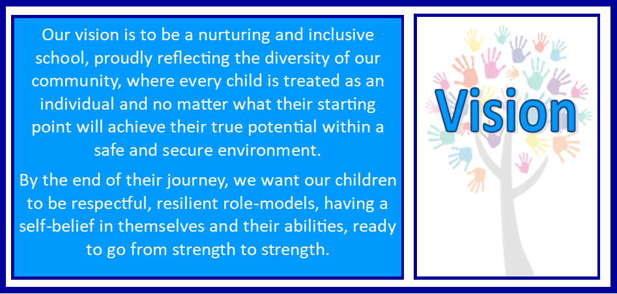
Safeguarding, Serious Incident Reporting and Health and Safety are regular agenda items, and the council is tasked with ensuring that all the relevant training, Risk and Fire Assessments and reporting procedures are kept up-to-date and adhered to. The Diocese has introduced a new Safeguarding ‘Dashboard’ and this is currently being assessed by our safeguarding officers.
The regulations also require the council to check the proper maintenance of all gas appliances, electrical installations and fire extinguishers, to make sure that all certificates are current, and to check that necessary performance licences are kept up-to-date. This is particularly important when it comes to renewing the insurances for both church and
hall. All relevant paperwork is checked by the Archdeacon (or his representative) at the Annual Visitation which usually takes place in the spring. This year we are also required to instruct our inspecting architect to carry out the ‘Quinquennial Inspection of the church and hall and this will have been completed by late spring.
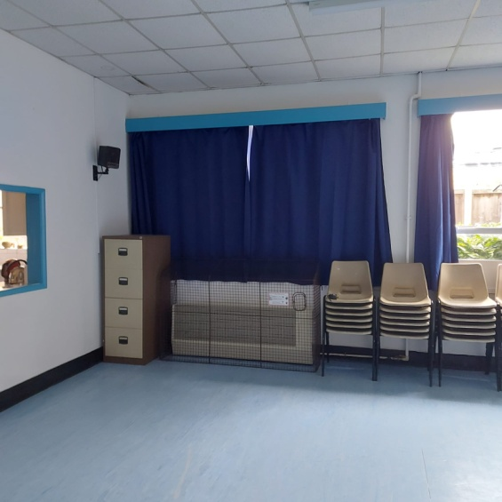
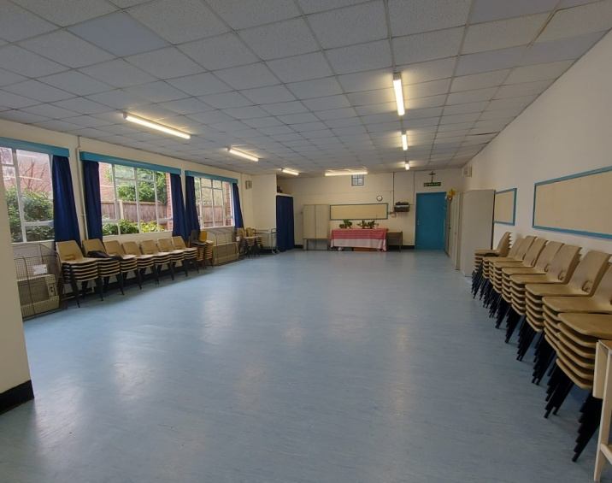
The Council’s responsibility for the care and maintenance of the church buildings also extends to the church hall which is normally used on a regular basis for a wide range of activities, and also as a meeting place for several community groups. That this building should continue to function, despite ongoing deterioration, will be a major challenge for All Saints’. However, thanks to a very generous legacy, and despite some challenges along the way, we continue to press forward with plans to consolidate and repair the structure of the church and replace the hall with a new building. You can read more about our plans, and how they are progressing, on pages 13-14. In the meantime we have carried out a thorough clean and re-decoration of the hall, including the provision of new curtains, and re-arrangement of the storage facilities. It is a great improvement and has made the whole space more welcoming.

The newly decorated church hall

The Parochial Church Council also bears overall responsibility for the finances of the parish, and there will be more information on this later in this report.
As in all matters the Council is required to follow the Data Protection regulations as applicable.

Objectives
To grow and foster our Parish Community is one of the prime objectives of the P.C.C. All Saints’ has a tradition of ‘Anglo Catholic’ worship stretching back over many years, and the council is anxious to maintain this with strength and determination. However, the age profile of our current congregation necessitates the need to explore new initiatives that will encourage not only children and their parents to join our worshipping community, but also those who might otherwise pass us by. In this context our ‘Mission-Action-Plan’ and links with our church school continue to be of increasing importance. We now have a representative on ‘Fidelium’ – a network of young Anglo-Catholic Christians in London who attend Fulham Parishes, and it will be interesting to see how this new initiative develops. We have also been represented at the Kingston Area Lay Conference, at a conference on Justice, Peace and the Integrity of Creation, at an event for young people from Anglo-Catholic Parishes, at the ‘Open Doors’ project and at the Bishop of Fulham’s Lay Congress.
We also try to ensure that we ‘keep in touch’ with those who, for whatever reason, cannot attend church regularly. This may be by phone, e-mail or through delivery of our Parish Magazine, but also with personal visits wherever possible. The covid pandemic may have faded into memory somewhat, but it presented us with new challenges, and important lessons were learnt that have enabled us to improve our service to our community.
Every December the council, in conjunction with our Social Committee, approves a calendar of events for the coming year which aims to appeal to as many people as possible through its variety and accessibility. These activities are promoted on our website, in our school, on ‘Facebook’ and in the parish magazine.
Worship – Congregational
The P.C.C. has ensured that access to the church is easy for the disabled and for those who are less mobile. A lit and level path to the west end of the church allows disabled access through the south door, which is wide enough for wheelchairs and pushchairs. Handrails have also been installed to either side of the steps leading to the main door, as well as additional grab rails on the doors themselves. The main doors can also be securely fixed in an open position. Sidespersons are on duty at all points of entry to assist as necessary. Toilet facilities incorporate special provision for the disabled, as well as a baby changing station for those with younger children. As part of our building plan we hope to further improve disabled access by constructing a new ramped entrance via the north door.
- Sunday worship is centred on our main Sunday service of Solemn Mass at 11.00.a.m. which attracts an average congregation of 38 adults and 7 children. Incense is used and the service is choral. There is also a team of servers, which will usually comprise a Master of Ceremonies, Thurifer, Crucifer and two acolytes. There are also normally one or two Eucharistic Ministers who will administer the Chalice.
Lay persons are encouraged to join our ‘reader’s list’ and they will read one of the lessons on a regular basis. Other members of the congregation lead the intercessions. We also actively encourage people to join our choir (Contact Mr. David Coram, organist), and serving team. (Contact Mr. Patrick Wood, Sacristan)
After the service coffee and biscuits are served by volunteers at the back of the church and once a month there are homemade cakes for sale.
It is vitally important to us that we ensure everyone receives a friendly welcome, and that any newcomer is greeted warmly and invited to stay behind afterwards to join us for coffee and a chat.

- There are normally two Low Masses during the week – at 7.30.p.m. on a Tuesday evening and at 11.00.a.m. on a Thursday morning. These services may expect a congregation of between 8 – 12 people on a regular basis. Mass on a Thursday is usually followed by coffee at the back of the church.

- With the exception of September, Solemn Evensong and Benediction is held on the third Sunday of each month. It is a sung service with both choir and servers present. Attendance is usually between 10 – 16 people. The time of this service varies according to the season.

- Information regarding Baptisms, Weddings, Funerals etc., are invited either by e-mail or telephone and anyone wishing to see Father Christopher personally can arrange a mutually convenient meeting using the same means.

- Our Walsingham Cell usually meets bi-monthly, on a Saturday in Church at 12 noon for a Mass dedicated to Our Lady, followed by refreshments and a meeting. The Cell, which has members from other nearby churches, aims to make a weekend pilgrimage to the Shrine once a year. We also have a small, but dedicated Rosary Group which meets on the first Sunday in the month at 6.00.p.m.

- There are of course additional services at various times throughout the year. These include Ash Wednesday, Holy Week, certain Saints’ Days, and on days surrounding the Great Festivals. In addition we often host the Guild of Servants of the Sanctuary – Fr. Christopher being chaplain to the Chapter of The Incarnate Word, S. Alban & S. Edward.

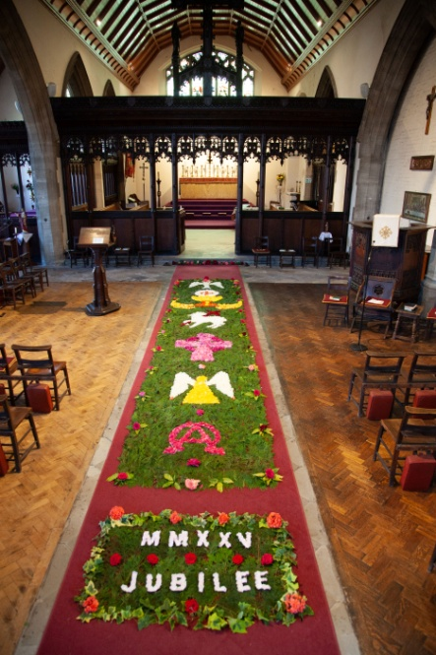
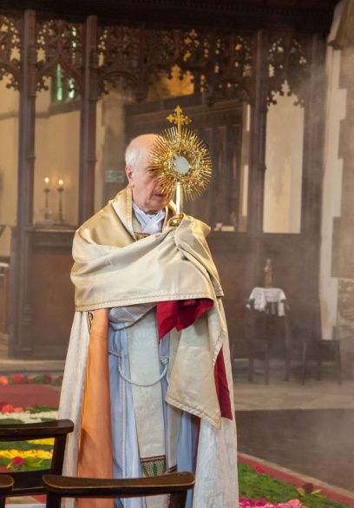
- For the festival of Corpus Christi we lay a carpet of flowers down the main aisle of the church. Provided that the school is not on holiday, we encourage some of the children to bring along their own petals and to lay their own design.
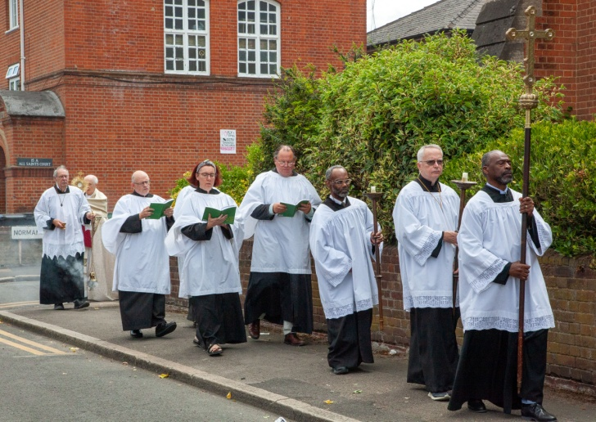

- Additional services are always advertised on our notice boards outside the church and hall, on our Facebook page, in our weekly news sheet, in our magazine and on the parish website.
Corpus Christi 2025

Worship – For The Children
- Junior Church
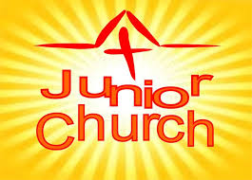
As part of our initiative to encourage families with young children to join our worshipping community Junior Church meets on the second Sunday each month in the S. Michael Chapel. Beginning at 10.00.a.m., it lasts for about 30 mins. Each meeting features a theme for the day which includes songs, prayers and activities in which all the children can take part. Parents and friends are all welcome to join in with the fun! Roger Stanley, who leads the group, hopes to expand the programme to include sessions in our school, and is always looking at varying the format to widen its appeal.

- Sunday School

On Sundays when there is no Junior Church, Roger Stanley occasionally leads an informal Sunday School in the church hall or, when the weather is fine, in our ‘Quiet Garden’. These sessions run in tandem with our Sunday Mass and the children come back into church prior to the administration of Communion. In addition there are various facilities for children at the back of the church which they can access as the need arises.

- All Saints’ C. of E. School

Several members of the Parochial Church Council serve on the Governing Body of the school, either as P.C.C. or S.D.B.E (Southwark Diocesan Board of Education) governors. The present co-chair of the school’s Governing Body is a member of the P.C.C. and the council is also represented on the school’s Faith Group which seeks to develop and strengthen the links between school and church. Our Organist David Coram, also serves on the Governing Body and hopes in time to establish a school choir which we hope will sing not only in the school, but also in church.
These links are highly valued, and the children experience Christian worship as part of their everyday life. Father Christopher leads assemblies in the school, and the whole school meets in the church throughout the year for services to mark the end of each term, and to celebrate the important festivals of the Church calendar. They also gather at All Saints’ for a service to mark All Saints’ Tide, and for their Christmas Carol services. On many of these occasions we welcome parents and friends to the church when we hope they will find us to be both welcoming and inclusive.
Some of the older children attend one of our weekday Masses to learn more about the meaning of the Eucharist. Children also come into church to learn about various aspects of the faith and the meaning behind some of the symbolism used as part of our worship.
Church and school also aim to work together in other ways whenever they can.
Each December the church hosts the school’s annual ‘Christmas Shop’ – a five day event during which all the children from the school visit the church to select and purchase Christmas gifts for their family and friends. The church is also represented at the school Summer Fair where members of the congregation usually help to man the ‘Cake Stall’ and share the profits!!
The P.C.C. also makes discretionary grants to help fund school trips for some of the less fortunate children from the school. This is something we are happy to do as part of our continuing commitment to the school, its staff and its pupils.
Worship and Outreach
- Our parish website gives up-to-date and detailed information on all our services, and also provides links to the other relevant sites of interest such as The Society, the Bishop of Fulham and the Diocese of Southwark. There are also additional resources for those unable to attend public worship including our own ‘Facebook’ page. Our monthly ‘Parish News’ Parish Magazine is published each month and is not only available in church, but is also posted out to as many people as possible. Many of the articles – including Fr. Christopher’s letter and the school news – are also posted on our website.
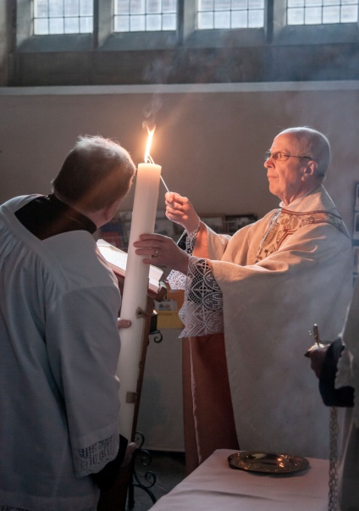
- Every year as part of our Lenten observance we hold a ‘Walk of Witness’ in the parish. This invariably receives a positive response with people often joining us either in prayer, or in the singing of some of the more familiar Lenten and Passiontide hymns. The following Sunday is, of course Easter Day when we hope as many people as possible will join us for the great Easter Festival and the lighting of the great Easter Candle
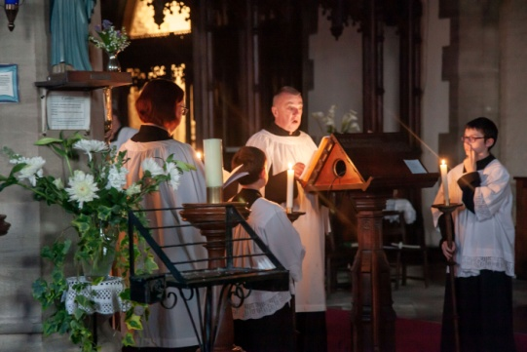
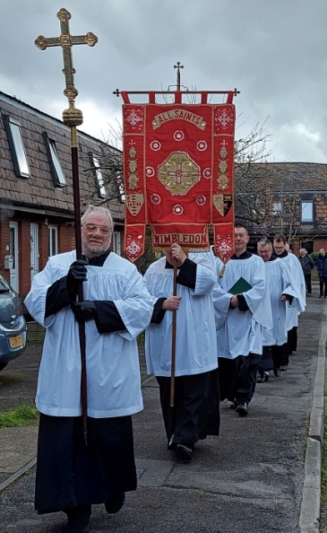
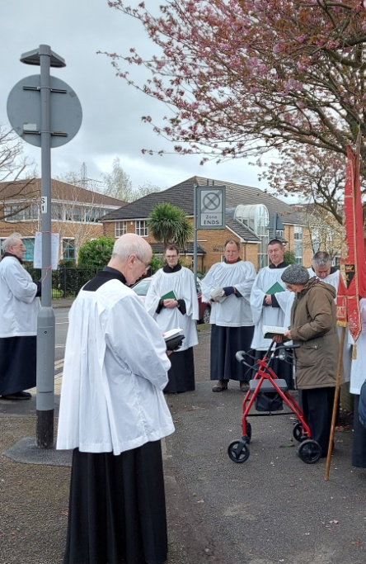

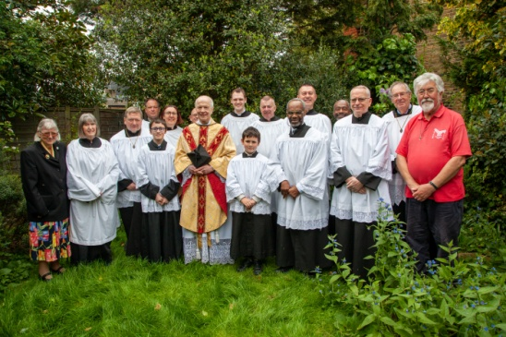
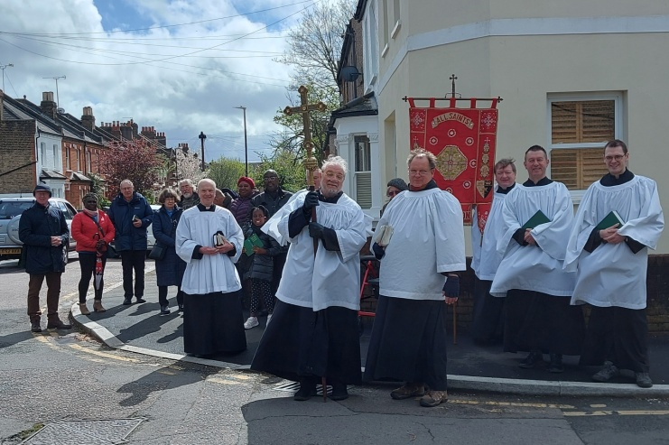
Walk of Witness and Easter Celebrations 2025

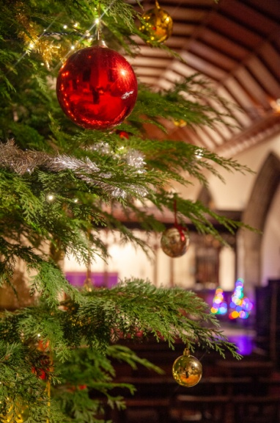
- Christmas is a joyful time for most and at All Saints’ we try to make it as traditional as possible. The church working party will fell the Christmas tree and manfully erect in it the church whilst the flower arranging team will provide an abundance of seasonal decorations.
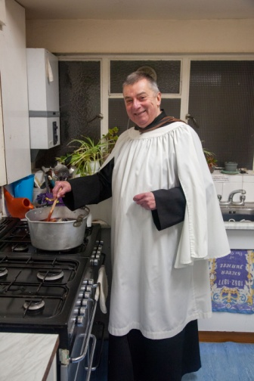
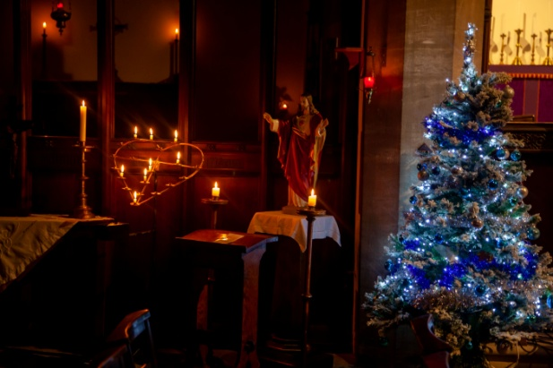
Our Carol Service by candlelight is particularly popular, attracting a number of people who might not otherwise attend church. Mulled wine and mince pies in the hall afterwards give the opportunity to strike up new acquaintances in a relaxed and convivial atmosphere, and hopefully encourage some to return on a more regular basis. On Christmas Eve we hold our ‘Christingle’ service, which is particularly aimed at young children. This has become increasingly popular - the children carefully carrying and placing the crib figures, holding their lighted ‘Christingles’ and joining with their parents as, in a darkened church, they gather round to sing ‘Shine, Jesus, Shine.’ A moment to treasure.
David Coram – master of the mulled wine!

Worship – Statistics

Communicants – January – December 2025

Overall the number of communicants over the past year has remained stable. The average number of Sunday Communicants in 2025 was 38 – exactly the same as the previous year! Weekday numbers were up by 97, returning an average attendance of 9. Numbers were up for All Saints’ Tide and Easter and also slightly up at Christmas. Other numbers were largely unchanged. In total there were 3,134 acts of Communion at All Saints’ in 2025 as compared to 2,892 in 2024. This is an increase of 242 or – in percentage terms - an increase of 7.9%

Children’s attendance – January – December 2025

Children’s attendance on Sundays has increased during the past year - the average attendance now being 7. School attendance was down by 279 –possibly reflecting the fact that their Remembrance Day service was not held in church. Junior Church has remained stable, but only eight children attended our Carol and Christingle services in 2025.
Other attendance – January – December 2025

Attendance at Evensong – which is held on the 3rd Sunday of each month - continues to average out at about 15. There was an increase in adult attendance at our School services, but elsewhere, numbers remained more or less consistent with the previous year. Southwark Cathedral was the venue for the Confirmation service at which three young members of our congregation were confirmed by the Bishop of Fulham. A total of 40 people attended Morning Prayer which replaced our usual Thursday morning Mass on several occasions in the autumn. There was one funeral attended by 82 people. There were four baptisms during 2025 – three of which were for children and one for an adult.

Activities
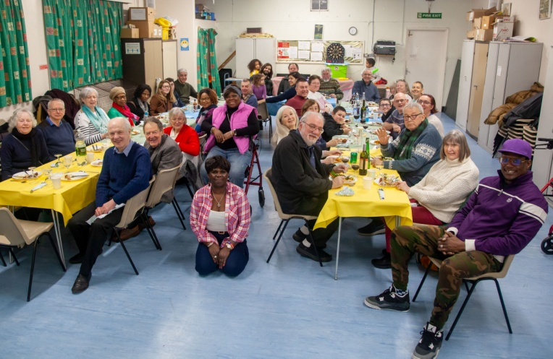
Overview
The P.C.C. appoints a Social Committee at its first meeting after the A.P.C.M. This group comprises primarily P.C.C. members, but also has the power to co-opt other members of the congregation who have particular gifts and talents that could be of benefit in making decisions with regard to the forward planning strategy. In partnership with our Parish Priest, the Churchwardens and the whole council, the Social Committee formulates a plan of activities for the coming year, encompassing not only events primarily aimed at fund-raising, but also planning occasions that appeal to the wider community and social gatherings that relate to the times and seasons of the year.
Our Caribbean Evening
- Church-Centred

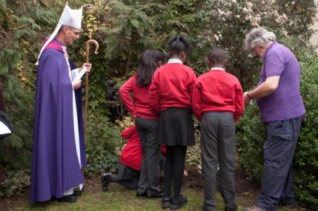
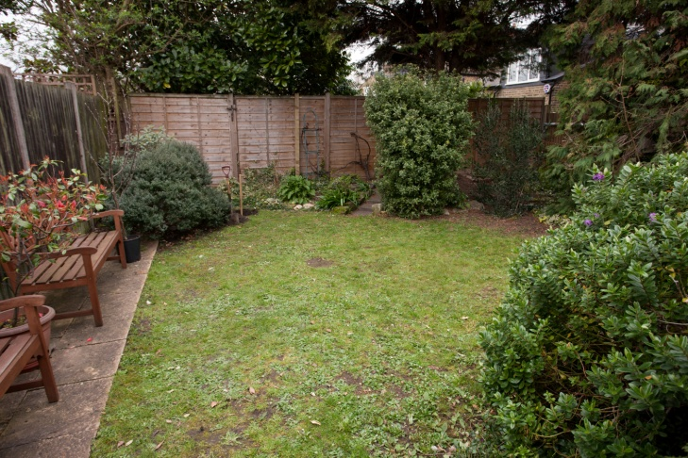
  - ‘The Quiet Garden’
The Quiet Garden was born out of the small plot of land to the south west of the church that remained after the Vicarage garden was fenced off. Dedicated by the Bishop of Kingston on 20th March 2019, when children from our school helped plant an apple tree and some bulbs, it is now not only a place for prayer and quiet reflection, but also an outdoor space that can be utilised in the warmer weather by ‘Teddy Bear’ Church and by our Sunday school children. The P.C.C. agreed that the garden should be affiliated to the ‘Quiet Garden Movement’ and listed on their website. Funded by the P.C.C., it is always open at the same time as the church, and also by prior appointment. It is also open on Friday mornings in conjunction with ‘Open Church.’ Access is either via the church or along the path that runs from All Saints’ road and under the west window.
The Bishop of Kingston Blessed the Quiet Garden in 2019
The Quiet Garden

  - ‘Open Church’
‘Open Church’ is an initiative designed to welcome anyone into church on a Friday morning. Coffee and biscuits (sometimes homemade cakes!) are served and church members are always on hand to greet visitors, some of whom may never have visited All Saints’ before. There is also the opportunity to light a candle for someone, to sit in silent prayer, or to just soak up the atmosphere of the building.
During the season of Lent it is expanded to include a ‘Lent Lunch,’ the proceeds of which usually go to the ‘Bishop of Southwark’s Lent Appeal.’

  - ‘Tuesday ‘Drop – In’
The Tuesday ‘Drop-In’ group is an initiative that offers the opportunity for people (some of whom may live alone) to meet with others and enjoy games, tea and coffee and some simple snacks – such as filled rolls etc. People are free to come and go as they please during the session, which runs from 12.30.p.m. – 2.30.p.m. As the group meets in the church hall, it also serves as a ‘warm space’ during the winter months.

  - ‘Working Party’
Our ‘Working Party’ comprises a small, but dedicated band of people that meet regularly on a Wednesday morning to maintain the church gardens, clean the church itself and do all those smaller jobs that would otherwise involve the church in extra expense. Our flower arrangers often join the group, and at Easter their numbers swell as people come along to help with the annual ‘spring clean’ of the church. Working together like this fosters love and care not only for the church buildings, but also for each other. It is very much the case that a Church that works together, stays together.

- For the Church and Community
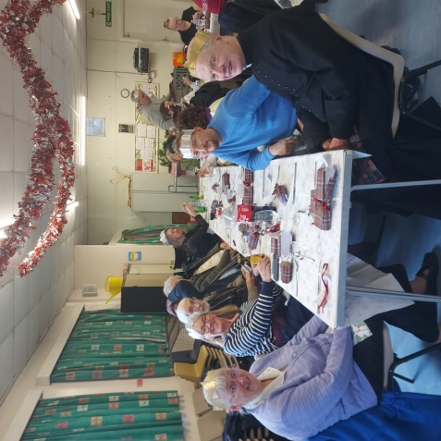
  - ‘Eating Out!’
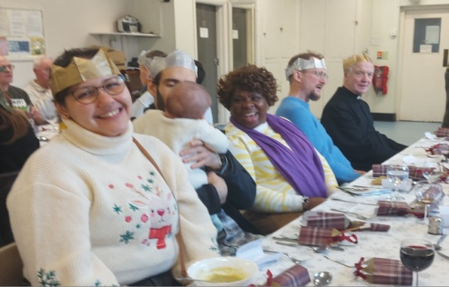
The real joy of food is being able to share it with friends, and one of the great joys of friendship comes from eating together. At All Saints’ this has become part of our social calendar, and we now plan a number of celebratory lunches each year – more if the occasion warrants it! Our lunches are open to all and aim to be as informal as possible. At Christmas we enjoy a sit-down Christmas Lunch which proves very popular with young and old alike!
Christmas Lunch 2025
Some of our social evenings feature food from other cultures and in the coming year we are promised delights from both Thailand and Morroco!

  - ‘Fun and Funds’
You will see from the financial statements that All Saints’ needs to raise additional funds to meet its liabilities each year, and to set aside money for future projects. The P.C.C. and Social Committee therefore plan a number of events each year to fulfil this need.
The Christmas and Summer Fairs are our largest undertakings and involve the most planning and commitment. As well as stalls run by the church, we have furthered our outreach by inviting third parties to run stalls of their own, and by asking the uniformed organisations to add their contribution to the mix. The added attraction of refreshments and lunches, plenty of advertising and attractive prizes, hopefully helps to encourage as large an attendance as possible.
Our ‘Cream Teas’ afternoon – which also incorporates a few stalls – is another opportunity to welcome people to our church in a relaxed and informal atmosphere. If the weather is fine tables are set up in the ‘Quiet Garden’ where tea, scones, strawberry jam and lashings of fresh cream - quintessential elements of an English summer afternoon - can be enjoyed in peace and tranquillity.
For those seeking an intellectual challenge our Annual ‘Inter-Church Quiz Nite’ is timed to coincide with our Patronal Festival celebrations. Planning for this popular event starts in the early autumn when invitations to take part are sent out to a number of local churches, as well as to our school. About eight teams take part and, despite the rivalry and maybe the occasional dispute, good humour abounds and a fun evening is had by all.

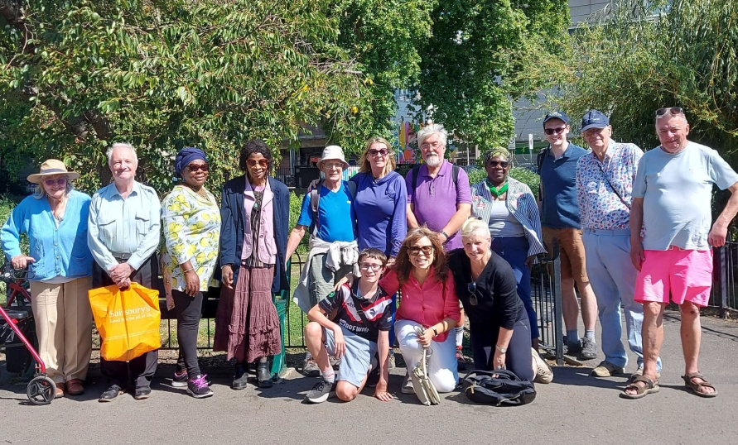
  - ‘A Walk in the Park’
Every year, on or around the August Bank Holiday, we hold our ‘Sponsored Walk’ – a leisurely stroll through country or town, taking in places of interest, and often visiting unfamiliar locations. People are invited to sponsor the walkers – the money raised usually specifically targeted at a particular project or need that the church might have. In 2025 – on a beautiful, but very hot summer’s day - we walked from All Saints, along the banks of the river Wandle, to its’ confluence with the River Thames. From there we continued to follow the river, ending our walk at Putney Bridge and the welcoming sight of a 93 bus home!!!
Sponsored Walk 2025
Purely for pleasure, and for a chance to get out together, Roger often organises walks at weekends throughout the year. These form part of our Mission-Action-Planning strategy and are open to all.

- ‘Spreading our Wings’

  - ‘Concerts’
The acoustics of the church are ideally suited to musical recitals, and we are keen to encourage performance related events throughout the year. Our choir visited S. Olave’s, Mitcham when they sang at their Advent Carol Service. Another Jazz Evening is planned for 2026 and no doubt time will be found to enjoy further performances from our choir and organist.

  - ‘Here we are!’
Every month the parish publishes a Parish Magazine which contains a letter from Father Christopher and news from our school and the wider parish. It also gives up-to-date information on services, impending events and those planned for the future. No charge is made for this, but donations are welcome. The magazine is distributed to all members of our regular congregation – to their homes if necessary – and is also available at the back of the church to anyone who might like one. On a weekly basis a service sheet is produced, which not only contains the hymns and readings for each Sunday, but also contains up-to-date details of all services and events for the week ahead, and advanced notice of upcoming happenings in the parish. It is designed to be taken home and referred to throughout the week.

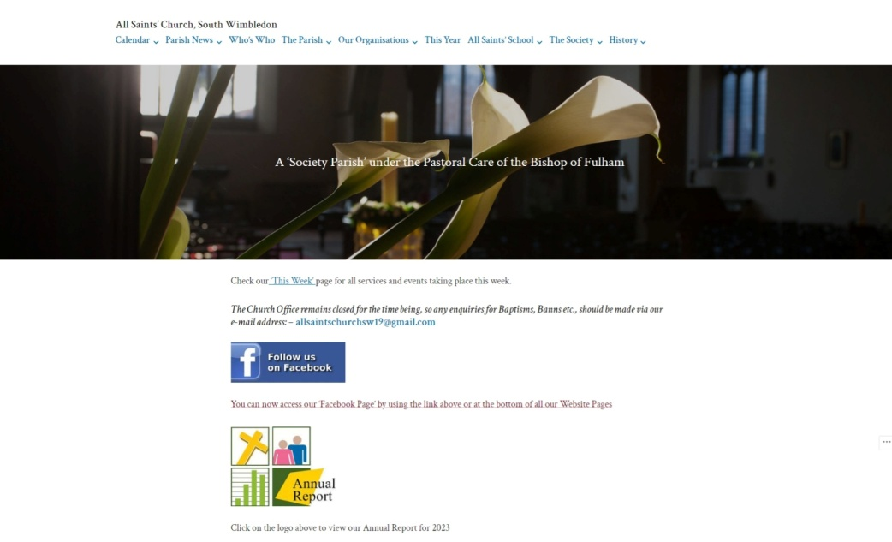
In tandem with the magazine the church has its own website packed with information on the church and its history, as well as the full church calendar, information on our church officers and details of contacts. In 2020 the website was completely overhauled, not only to improve its appearance and ease-of-use, but also to ensure that it meets current security protocols.

Website Statistics 2025

The average number of visitors per month for 2025 was 409. The average number of views per month was 1022
The most popular pages are: - All Saints’ Church (3,229 hits), This Week (790 hits), Prayer Resources (763 hits), Who’s, Who (409 hits) and Calendar (403 hits). Other popular pages are All Saints’ School, Parish News and The Church Hall.
The most visitors come from the U.K., (10,976 views) followed by the U.S.A, (680 views)
Website Visiting Statistics by country – 2025
U.K. 10,976. U.S.A. 680. Germany 307. New Zealand 140. Australia 78. China 54. Belgium 49. Canada 46. France 25. Ireland 22. Japan 20. Chile 19. Spain 18. Netherlands 14. Italy 13. Vietnam 11. Sweden & India 10. Singapore/Phillipines/Norway/Brazil 8. Greece 7. Turkey/Nigeria/Indonesia/Hong Kong/Egypt 5. Ukraine/Pakistan/Jersey 4. South Africa/Taiwan/Russia/Poland/Mexico/Kenya/Finland/Barbados/Austria/U.A.E.3. Zimbabwe/Portugal/Latvia/Cambodia/Iraq/Hungary/Columbia/Bahrain 2. Uganda/Trinidad&Tobago/Thailand/Slovakia/Peru/Malasia/Malawi/Iceland/Israel/Guernsey/Denmark/Czechia/Cyprus/Switzerland/ Bangladesh 1.

We also have our own page on which notable events are advertised and photos of special occasions posted.
Our notice boards also carry detailed information about services and events happening in and around the parish.
Going Forward
- Our Church Hall
The Church Hall fulfils an important role as a meeting place for the church, as a venue for many of our fund-raising events and as a facility that can be used by the wider community. For a very reasonable hourly fee, and subject to the approval of the P.C.C., the hall can be hired for a variety of functions.
In addition to its use by our own church community, it is utilised by various groups and clubs, and parties – especially for children - often grace the hall on a weekend.
Of necessity we are required to ensure that our hiring agreement is up-to-date with standards set by the Diocese and local authority.
The money raised from our hall lettings forms a significant part of our income, but the state of the hall building itself is giving increasing cause for concern and has probably been impacting on the number of lettings that we attract. Built in the 1950’s and with a concrete-bound asbestos roof, the building is now barely watertight. The floor slab suffers from the ingress of damp and there are settlement cracks to some of the walls.
We have made some improvements with the installation of L.E.D. lighting throughout, and have recently commenced work on a programme of complete re-decoration. However, the P.C.C. accepts that there will come a time when complete replacement of the structure will be necessary. Later in this report you will find details of how we are progressing our plans.

- Our Church

- The Building
Our Quinquennial inspection – a Diocesan requirement – was last carried out in 2021 and is due again in 2026. This comprehensive examination of the church buildings was completed by our architect, who provided a detailed report highlighting what work was required along with a suggested timescale for completion. Following these recommendations we now have a plan for stabilising the structure of the church for the future and you will find details later in this report.
In the interim however, the council is mindful to mitigate the need for emergency repairs by ensuring that a routine schedule of maintenance is in place, and that all roof slopes, gutters and rainwater goods are inspected on an annual basis.
Our five-yearly electrical inspection fell due at the end of 2021 and all the wiring was passed as safe. In addition – and as an insurance requirement - all portable items were checked in 2025 as to their electrical safety. Our next full electrical inspection is due in 2027.
With regard to our gas appliances, these are checked annually with regard to their safe operation. Any necessary repairs are actioned promptly and safety certificates issued.
All fire extinguishers are of the correct type and placed appropriately. They are serviced annually.
Our insurance company regularly check to ensure that we are not falling short on any of their requirements with regard to continuing cover. As a result we have installed some extra signage and insulated some exposed pipe work.

- A ‘Green Church’
The Diocese actively encourages churches to be as ‘green’ as possible. However, a building such as ours is inevitably costly to heat and light – even more so now considering the cost of fuel. The ‘energy footprint’ that the Diocese requires us to complete each year unsurprisingly reveals that our energy consumption is high and our efficiency low. However, all lighting has now been converted to L.E.D. which reduces our electricity usage, and we are restricting the use of gas as much as possible despite the challenges faced in trying to heat the building to a comfortable temperature. At all times the council seeks to get the best available energy deals and, as you will see from our Building Plan, we are actively pursuing improvement to the insulation of the buildings, the provision of more efficient heating and the installation of photo-voltaic cells to the roof slopes.
As part of our service to the community a defibrillator is installed in the hall passageway so that it is available to users of both church and hall. This is checked regularly to ensure that it is ready for use.

- ‘Seating’
The chairs in the church are probably original to the building and an increasing number are showing signs of instability. The ‘church working party’ aims to keep them repaired and stable, but those with the most serious defects have had to be removed. Fortunately the installation of pews in the chapel released more chairs for use in the main body of the church. The council has set aside funds for the eventual replacement of some of the seating, and a number of lightweight benches were purchased for use by the children when they school visit. To date various forms of seating have been appraised, and some designs considered, but no decision has been reached. We hope to forward this in the future.

- ‘The Benefice’
The Diocese wrote in September 2021 to confirm that the ‘Benefice’ of All Saints’ was to be suspended for a further five years, citing possible ‘pastoral re-organisation’ as the reason behind their decision. The P.C.C. made a considered response to the letter, but the situation is not likely to change until the suspension is reviewed in September 2026
The P.C.C. discussed the situation with the Bishop of Fulham, the Area Dean and the Archdeacon of Lambeth and a decision was taken to the effect that, although Father Christopher would no longer be able to continue as Priest-in-Charge when his licence expired in early March 2023, he was given ‘Permission to Officiate’ by the Bishop of Southwark and thereby continue to exercise his ministry at All Saints’. Father Christopher’s P.T.O. has been further extended, but the parish remains in interregnum and planning for the future continues to be an important consideration.
Building for the Future
You will have read earlier in this report of the ongoing concerns regarding certain aspects of the main church building and of the structural integrity of the church hall. For some time now we have been trying to save some of the money from our hall lettings to build a fund for reconstruction of the hall, but progress has been slow. Similarly we have struggled to find money for increasingly urgent repairs to the church itself.
However, as most of you will know, the church was in receipt of a very generous legacy from the estate of the late Gwen Watts – a lifelong worshipper and supporter of All Saints’. This has enabled us to embark on an ambitious plan of refurbishment and rebuilding that we hope will secure the future of our church and hall.
In conjunction with our architect, Marcus Beale, plans were drawn up detailing various options for both the church and hall.
In all cases essential work would be carried out to the church building itself, including repairs to (or complete replacement of) the roof and repairs to the stonework. With regard to the hall there were effectively three options: -
  - To retain and re-furbish the existing building.
  - To demolish the existing building and rebuild a slightly larger single-storey hall.
  - To demolish the existing building and rebuild a three-storey hall with lifts and two hall areas.
In addition to these fundamental plans there are options to install solar panels, under-floor heating in the church, a new disabled entrance to the north, a tea and coffee point at the back of the church, new vestries, a roof terrace, new kitchens and dedicated meeting rooms.
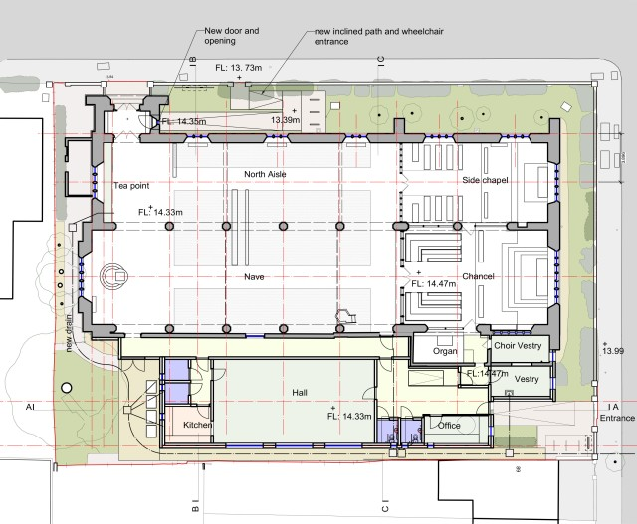
After much discussion and consultation it was decided that we should proceed with option b) – that is to carry out repairs to the church - hopefully including underfloor heating, solar panels and other improvements – and to demolish and replace the church hall with a modern single storey building on a slightly larger footprint. To this end we invested in detailed drawings and costings in preparation for submitting bids for grant funding.
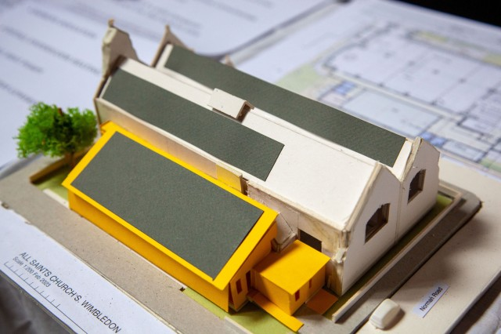
Scale Model showing the proposed new building

Floor plan detailing the proposed re-development of both church and hall

In late 2023 we submitted an ‘Expression of Interest’ form to the Heritage Lottery Fund which was sadly rejected. However, together with our architect, we have now carefully examined the criteria for grant applications and are working on a new application, based on the principles listed below, which we hope will meet with more success.

The Heritage Lottery Fund’s guidance for applications is now based on four principles that guide their entire decision making.

They are:-

Saving heritage - Conserving and valuing heritage, for now and the future.

Protecting the environment - Supporting nature recovery and environmental sustainability.

Inclusion, access and participation - Supporting greater inclusion, diversity, access and participation in heritage.

Organisational sustainability - Strengthening heritage to be adaptive and financially resilient, contributing to communities and economies.
We welcome any input that might help us to formulate a new application which meets all these criteria.
Overall this is a very exciting project for All Saints’ which when completed, will secure its future for generations to come and comprehensively fulfil the terms of the legacy that made it all possible.
Finance

The Parochial Church Council has overall responsibility for the finances of the parish. The church treasurer is appointed at the first meeting of the council following the A.P.C.M., and we also have a secretary who deals specifically with our Covenanted Giving and ‘Gift Aid’ returns. (At present this is all dealt with by our treasurer). The finances of the parish are an agenda item for every meeting of the council and, in conjunction with the treasurer’s report, the council will discuss and decide our money management going forward. It will also consider the administration of the Reserve Account, with regard to both ‘restricted’ and ‘unrestricted’ funds, and how these might be used for future projects, or to meet unexpected expenditure.

Every year the council is required to determine the sum of money to be set aside for ‘The Parish Support Fund.’ This is an annual payment to the Diocese of Southwark – sent in monthly instalments - which helps to pay for the centralised support given to parishes. Careful consideration has to be given to this with due regard to our actual and expected income and the council is always mindful of the fact that this sum has to be affordable.

The overall running costs of the church have large bearing on our decision making with regard to the P.S.F., but we do try to be as generous as we can. Early in the autumn Allison - our Treasurer - provides an update on our Budget, detailing the current financial situation, and providing projections with regard to the expected state of our finances by the end of the year. For 2026 the Diocese considered the Indicative Cost of Ministry at All Saints’ to be £35,000. This comprised £19,300 for ‘National and Diocesan Training, curate’s stipends and other ministerial support, and £15,700 for ‘Enabling and support functioning for parishes. After due consideration, and with some reluctance, the P.C.C. decided to raise our contribution to the P.S.F. by the amount requested by the Diocese – this being an increase of 5.7%.

I mentioned earlier our ‘Energy Footprint’ return. By submitting details of our energy usage in conjunction with the size and construction of the building an estimate of energy efficiency can be ascertained. Unsurprisingly, given the nature of construction of the building and general lack of insulation, All Saints’ does not score well! However, our L.E.D. lighting is saving us money and going some way towards reducing our carbon footprint. On a more positive note our plans for the refurbishment of the church and construction of a new church hall would render All Saints’ carbon zero! A goal worth aiming for!

With regard to the overall financial position of the parish, the Parochial Church Council will approve the accounts prior to the A.P.C.M. These accounts are examined by our Independent Examiner.

A full financial report will be given by the Treasurer at the Annual Meeting and all the accounts will be available for inspection.
Structure, Governance and Management
The Parochial Church Council is a corporate body established by the Church of England and operates under the Parochial Church Council Powers Measure. The P.C.C. is a Charity and its members are appointed as set out in the Church Representation Rules.
At All Saints’ the membership of the P.C.C comprises the Parish Priest, churchwardens, ex-officio members of Diocesan and Deanery Synods, and members elected by persons recorded as being on the electoral roll of the church. The Council also has the power to co-opt additional members as it sees fit. All those who are eligible are encouraged to register on the electoral roll and stand for election to the P.C.C. It should be noted here that the electoral roll was subject to a complete revision in 2025 and the number on the Roll at the A.P.C.M stood at eighty-six.
The P.C.C. has complied with the duty under section 5 of the Safeguarding and Clergy Discipline Measure 2016 (duty to have due regard to House of Bishops' guidance on safeguarding children and vulnerable adults.) The Council has also voted to adopt both the ‘House of Bishop’s 2017 Statement on Safeguarding’ and the ‘Diocesan Safeguarding Policy.’ Council members are required to complete safeguarding training and any other training pertinent to posts held.
To date the Council has met five times since the last A.P.C.M. with a commendable average attendance of 16 members (85%). A least one further meeting will be held before the A.P.C.M. to approve the accounts and this report.
At the first meeting of the council following the A.P.C.M., the Vice Chair, Treasurer, Electoral Roll Officer and Secretary are elected. A list of those wishing to serve as sidespersons will also be approved. At various times, and as appropriate, the P.C.C. will appoint two ‘Safeguarding’ Officers, two ‘Serious Incident Reporting’ Officers and P.C.C. governors to the school.
The council also normally appoints two committees: - The Standing Committee and The Social Committee. The Standing Committee has the power to transact the business of the Council between P.C.C. meetings, subject to any directions given by the Council. The Standing Committee’s role is therefore subservient to the P.C.C. The Social Committee is primarily charged with the planning and delivery of all social events that may be held throughout the year and has the power to co-opt additional members as and when it sees fit. As we are currently pursuing a major building project the Council has also appointed a Building Committee to oversee this undertaking which is now under the chairmanship of Mr. Martin Kelly.

Administrative Information
- Contact Details
  - All Saints Church, All Saints Road, Wimbledon, London SW19 1BU.
  - Church Telephone number: - 0208 542 5514
  - E-mail: - allsaintschurchsw19@gmail.com
  - Website: - https://allsaintschurchsouthwimbledon.com/
  - Facebook: - All Saints South Wimbledon | Facebook

- Parochial Church Council
P.C.C members who have served at any time from the date of the last A.P.C.M until the date this report was approved are:-
a. Ex Officio members: -
Mr. Roger Stanley......................................................Churchwarden & Vice Chair
Mr. Christopher Maurice ...........................................Churchwarden.
Mr. Patrick Wood....................................................... Diocesan Synod Representative.
Mrs. Linda Maurice....................................................Diocesan Synod Representative.
Miss Jenny Hardy.......................................................Deanery Synod Representative.
Mrs. Shirley Walker-Grant........................................ Deanery Synod Representative.
Mr. Malcolm Ford...................................................... Deanery Synod Representative

- Elected members: -
Mr. David Coram. Mr. Tom Wrench.
Mr. Nigel Grinsted. Mrs. Elizabeth Hayter.
Mr. Martin Kelly. (Deputy Churchwarden & Deputy Vice Chair of the P.C.C.)
Mrs Eleanor Spender. Mrs. Allison Scandrett.
Mr. Peter Scandrett. Ms. Eileen Walker.

- Co-opted member: - Fr. Christopher Noke (Parish Priest)

- Officers of the P.C.C.: -
Parish Secretary...................... ...........Mrs. Linda Maurice
Church Treasurer...............................Mrs. Allison Scandrett
Free-Will Offering/Gift Aid.............. Mrs. Allison Scandrett
Electoral Roll Officer.........................Miss. Jenny Hardy
Safeguarding Officers.........................Mr. Peter Scandrett, Mrs. Linda Maurice
Serious Incident Reporting Officers...Fr. Christopher Noke, Mr. Martin Kelly
P.C.C. School Governors................... Mr. Martin Kelly, Mrs. Allison Scandrett,
Mr. David Coram.
SDBE School Governors*..................Fr. Christopher Noke, Mr. Tom Wrench. Mrs. Nathalie Love
Miss. Jenifer Hardy
*All SDBE Governors are approved by the P.C.C.

- Committees of the P.C.C.: -
Standing Committee:-
Ex Officio: - Fr. Christopher Noke (Parish Priest), Mr. Chris Maurice, Mr. Roger Stanley.
Elected Members: - Mr Martin Kelly, Miss. Jenny Hardy, Mrs. Linda Maurice, Mrs. Allison Scandrett, Mr. Peter Scandrett

Social Committee: -
Mrs. Elizabeth Hayter (Chair). (Other members of this committee to be appointed by the Chair.)

Building Committee: - Fr. Christopher Noke, Mr. Roger Stanley, Mr. Chris Maurice, Mr. Martin Kelly (Chair), Miss. Jenny Hardy, Mr. David Coram, Mrs. Linda Maurice, Mr. Ray Hayter, Mrs. Allison Scandrett and Mr. Peter Scandrett.

- Business of the P.C.C.: -
The business of the council is based on a standard agenda with supplementary items added as necessary. The council will discuss and accept the previous meeting’s minutes, receive any notices from the chair and note any recent correspondence. There will be updates on our finances, the church fabric, All Saints’ School and reports from the safeguarding and serious incident reporting teams. The council will also receive updates from the Social Committee. If the council agrees other items may be considered at the end of each meeting.

- Parish Administrator: - Miss. Jenny Hardy

- Independent Examiner: - Mr. John Helm (Tandem Accounting) N19 3AL

- Elections 2026
  - Merton Deanery Synod:-
Three persons to be elected in accordance with the numbers on the Electoral Roll.

  - All Saints’ Parochial Church Council: - Three persons to be elected. (to hold office for three years)
The terms of office of the current elected members are as follows:-
To stand down in 2028: - Mrs. Allison Scandrett, Mr. Martin Kelly, Mr. David Coram.
To stand down in 2027: - Mr. Nigel Grinsted, Mr. Peter Scandrett, Ms. Eileen Walker
To stand down in 2026: - Mrs. Elizabeth Hayter, Mrs. Eleanor Spender, Mr. Tom Wrench.

  - Southwark Diocesan Synod: -
No election to be held this year.

Secretary’s Concluding Remarks

The parish still remains in interregnum, but we are delighted that Fr. Christopher’s ‘Permission to Officiate’ continues to be extended by the Bishop of Southwark. I am sure that you will all join me in thanking Fr. Christopher for his continuing ministry here at All Saints’. We owe him a great debt of gratitude. I have already stated in my report that the current ‘Suspension of the Benefice’ expires in September 2026 and we await with interest the direction in which the Diocese propose to take us. With this in mind a strong, dedicated and determined P.C.C. will be required to take the parish and its underlying principles forward.
I would also like to record my thanks to all members of the P.C.C. for their hard work and dedication throughout 2025. Attendance has been admirable throughout. The Social Committee have once again provided us with some excellent entertainment and culinary delights on a regular basis, and the time and effort put in across all aspects of our church life by so many people has ensured the smooth running of the parish for another year.
Elections to the Diocesan Synod were last held in 2024 and Patrick Wood and I were elected to serve. In 2026 elections will be held for Deanery Synod and, given the numbers currently on our Electoral Roll, we are entitled to elect three persons to serve for a term of three years. Information on the role of Deanery Synod members is available at the back of the church.
Our building plans are still very much a reality and, although our first Grant Application was turned down, there is every reason to suppose that, with the support and help of our architect and the enthusiasm of our Building Committee, grant funding will become available. We are preparing a new ‘submission document’ that we hope will meet the required criteria and that should be submitted this year. We should continue to feel optimistic for the future.
During the past year our Safeguarding Officers continued to update our D.B.S returns (Disclosure and Barring Service) which are a requirement for officers of the church and members of the P.C.C. Before this process could be completed however, a serious data breach occurred when the software provider for Access Personal Checking Services suffered a cyber attack which compromised data used in our DBS checks. In this instance one member of the P.C.C. had had their data compromised. All necessary steps were taken promptly to mitigate the occurrence but, although the Diocese has now changed their systems, our DBS applications are currently on hold. Some of our P.C.C. members attended a training session run by the Diocese on Domestic Abuse in early 2025 and it is hoped that more training of this sort can be arranged in the future. The Diocesan Safeguarding Audit was returned by our Safeguarding Team last March and highlighted the requirement to ensure that outings etc. were properly ‘risk assessed’ and that contact names and next of kin – where appropriate – should be listed.
The P.C.C. continues to support our school in every way. Children and their parents are welcomed into the church on several occasions throughout the year and, as has become customary, the ‘School Shop’ took place in the church during December. I am also delighted to report that the school had a very successful ‘Ofsted’ inspection in 2025. The report begins – “This nurturing school’s values of ‘compassion, love and community’ are clear to see in pupils’ exceptional behaviour,” It goes on to make the following statements: - ‘Quality of Education’ – Good. ‘Behaviour and Attitudes’ – Outstanding. ‘Personal Development’ – Outstanding. ‘Leadership and Management’ – Good. ‘Early Years Provision’ – Good. Congratulations to everyone involved.
We have also welcomed some year 4children from Garfield School – which is also in the parish – who visited last June to learn about the church and how the bible is used in our services.
During the past year our Mission-Action Planning work has continued and we are now looking to explore further ways of developing our plans in that direction.
Around the church several of the trees that were fast becoming unmanageable have been partially felled and tidied. This has greatly improved the amount of light reaching the west end of the church and has also been of considerable benefit to our neighbour who now has the advantage of improved light to the back of her house and garden. On a similar subject, the council were threatened with action if the hedges surrounding the church were not trimmed back to the boundary line. My thanks to the Church Working Party who actioned this with immediate effect.
I am sad to report that Maureen Wells – a long standing member of our congregation passed away during the past year. Her Funeral Service was held in church followed by a cremation at Lambeth Crematorium. May she rest in peace.
The P.C.C. has lately received requests for cremated remains to be buried in the gardens surrounding the church and we have already consulted the acting Archdeacon as to the procedures that would need to be followed. The P.C.C. is in favour of this going forward and the selection of a suitable site and application for a Faculty will be taken forward this coming year.
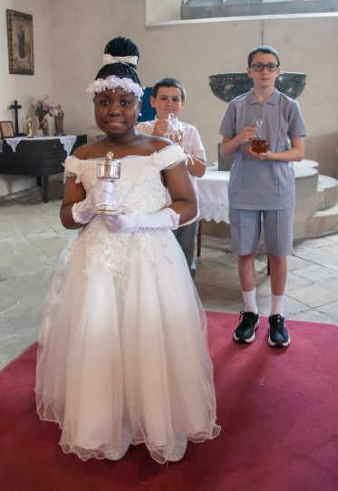
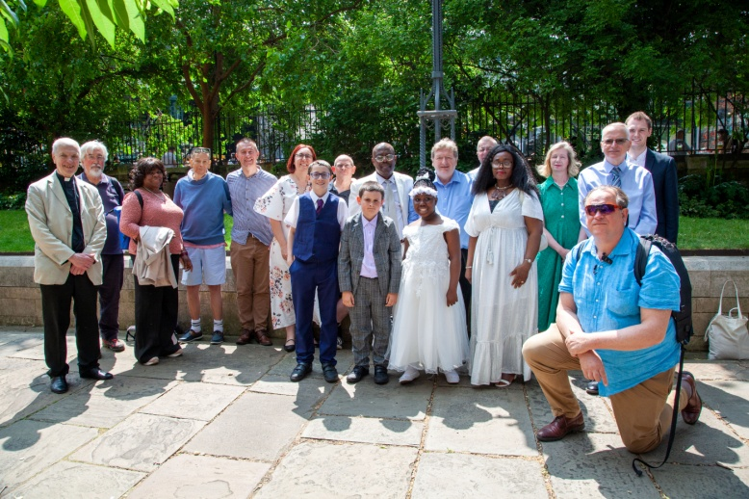
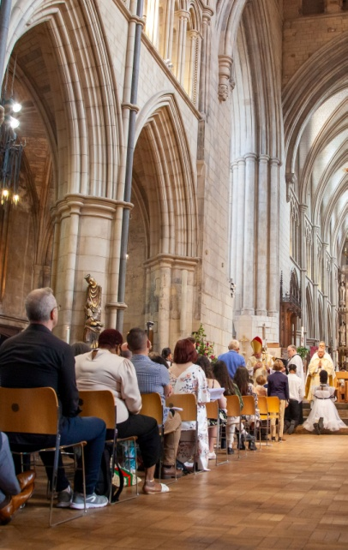
Some members of the P.C.C. were delighted to attend Southwark Cathedral to be present at the Confirmation of three of our young people – James, Christian and Isobel – by the Bishop of Fulham. It was a really joyous occasion and lovely to see them receive Communion with us all at All Saints the next day.

Confirmation at Southwark Cathedral

It was also a great pleasure to welcome back Bishop Peter Wheatley who celebrated and preached at our Solemn Mass for All Saints’ Day in 2025. Bishop Peter has been to All Saints’ on several occasions and it is always a pleasure to welcome him back.
Congratulations too to all those Baptised at All Saints last year and to our Organist David Coram who celebrated his 75th Birthday with us.
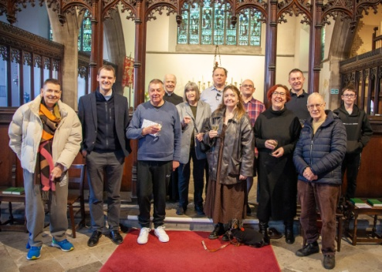
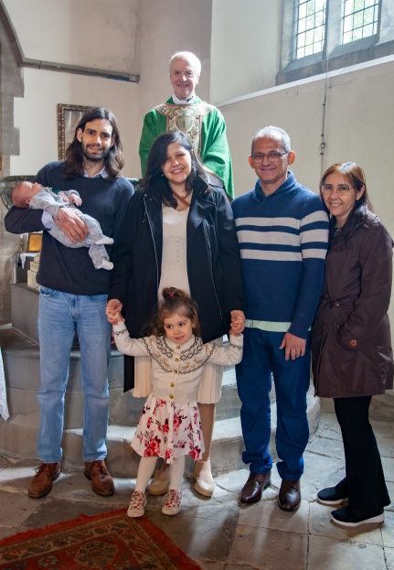
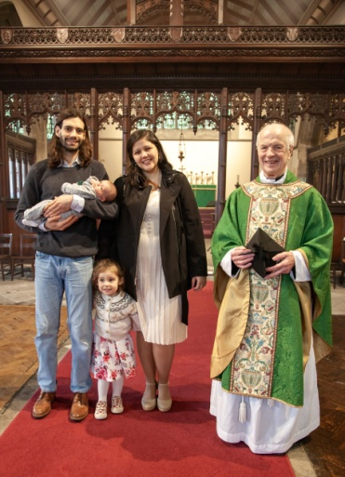

David’s 75th Birthday and Margot’s Christening

All Saints’ is a real Christian Family - welcoming, caring and loving in every sense. It is a privilege to be part of it.

Finally you will know that Nigel, a long serving member of the P.C.C., has recently undergone a long period of ill health. Following extensive surgery he is now well on the road to recovery. We thank God for his recovery and continue to hold him in our prayers.

Linda Maurice

Secretary to the P.C.C. – April 2026

Approved by the P.C.C and signed on their behalf by:- ________________________________

Date:________

